Q1:

Code:

#include <iostream>

#include <string>

using namespace std;

template <class t>

class Student

{

private:

t Roll, Name, Section, Course[5];

public:

void setName(t a)

{

Name = a;

}

void setRoll(t a)

{

Roll = a;

}

void setCourse(t a[])

{

for (int i=0;i<5;i++)

{

cout << "Enter Course Number " << i + 1 << " : ";

Course[i] = a[i];

}

}

void setSection(t a)

{

Section = a;

}

t getName()

{

return Name;

}

t getSection()

{

return Section;

}

t getRoll()

{

return Roll;

}

t getCourse()

{

return Course;

}

};

int main()

{

string str;

Student <string> name;

cout << "Enter Name: " << endl;

cin >> str;

name.setName(str);

Student <string> roll;

cout << "Enter Roll Number: " << endl;

cin >> str;

roll.setRoll(str);

Student <string> sec;

cout << "Enter Section: ";

cin >> str;

sec.setName(str);

cout <<"Name: "<< name.getName() << endl;

cout << "Roll Number: " << roll.getRoll() << endl;

cout<< "Section: " << sec.getRoll() << endl;

system("pause>0");

}

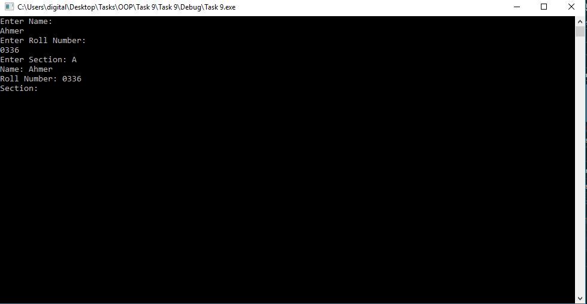

Q2:

Code:

#include <iostream>

using namespace std;

template <class T>

T isPrime(T num) {

int i = 2;

while (i <= num / 2) {

if (num%i == 0)

return 0;

else

i++;

}

return 1;

}

int main() {

int a;

cout << "Enter the Range to which you want to check prime Numbers: ";

cin >> a;

cout << "Prime Numbers: ";

for (int i = 1;i <= a;i++)

{

if (isPrime<int>(i) == 1)

{

cout << i << " ";

}

}

system("pause>0");

return 0;

}



Q3:

Code 2:

#include <iostream>

#include <string>

using namespace std;

template <class t, class f>

class Baseball

{

private:

t Name;

f HomeRuns;

public:

void setName(t T)

{

Name = T;

}

void setRuns(f T)

{

HomeRuns = T;

}

t getName()

{

return Name;

}

f getHR()

{

return HomeRuns;

}

};

int main()

{

Baseball<string, int>\*b;

int size;

int run;

string name;

cout << "Enter Number of Players You wanna Enter:";

cin >> size;

b = new Baseball< string, int>[size];

for (int i = 0; i < size; i++)

{

cout << "Enter Name of Player "<<i+1<<" : ";

cin >> name;

b[i].setName(name);

cout << "Enter Number of Home Runs Hitted : ";

cin >> run;

b[i].setRuns(run);

}

for (int i = 0; i < size; i++)

{

cout << "For Player " << i + 1 << " : " << endl;

cout << "Name: " << b[i].getName() << endl;

cout << "Number of HomeRuns: " << b[i].getHR() << endl;

}

system("pause>0");

}

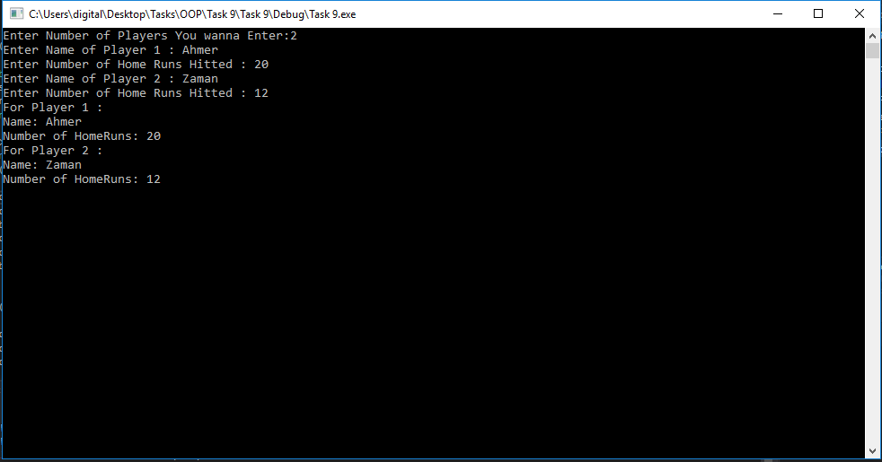

Q5:

Code:

#include <iostream>

using namespace std;

int main()

{

int a, b, c;

bool done = false;

do

{

cout << "Enter First Number: ";

cin >> a;

cout << "Enter Second Number :";

cin >> b;

try

{

if (b == 0)

{

throw "Math Error! Division by Zero is not Possible! Try Again";

}

c = a / b;

cout << "Answer= " << c << endl;

done = true;

}

catch (char const\* msg)

{

cout << msg << endl << endl;

}

} while (!done);

system("pause>0");

}

